B2B Helper Tools – Setup

1. Install Oracle client.
   1. Located at: \\rocweb01\d$\WestoverMatt\ODTwithODAC112021.zip
   2. Once installed, the Oracle.DataAccess dll to use can be found at:
      1. C:\app\<username>\product\11.2.0\client_1\odp.net\bin\2.x
   3. Use the tnsnames.ora file found at \\rocweb01\d$\WestoverMatt\ and place in the following location: C:\app\<username>\product\11.2.0\client_1\Network\Admin
2. Create the database and tables from the create scripts in MarketingGenerator.DB project.
   1. Set up web.config with proper connection string values (see current configs).

# Marketing Generator WebApp

The Marketing Generator WebApp is located on ROCWEB01 at:

<http://rocweb01.wwwint.corp/B2BMarketingGenerator/> (test) <http://rocweb01.wwwint.corp/B2BMarketingGeneratorProd/> (production)

The test app points at ROCSQT01\B2BProductCatalog and the production points to ROCSQP01\B2BProductCatalog. The app is pretty straightforward and has directions on it.

Note: The generator piece only works for US. The web app is still used to update the marketing info from B2C by loading XML files from Product Management.

# Marketing Info Generator (MIG) Service

The Marketing Info Generator Service is a Windows Service that when run will monitor the folder specified in the parameters for a file (*.SND) which triggers it to read Excel files containing marketing data and ITE files generated in SAP. It will parse the spreadsheets and add all the marketing data to the database. Once done, it will compare the values stored in the database against those contained in the ITE file. This will filter out the styles that are not in the ITE and move them to an exceptions table. The service will then generate the proper marketing files for iCongo and all the images for the style numbers. Images will only be generated if they were not created previously (it does check for updates, however) to reduce calls to the image server. It is important that the Excel files all be moved to the folder prior to the SAP files. Also, US and Canada both use the same tables in the database for now, ~~so they~~ *~~cannot~~* ~~be run simultaneously~~. After the ITE process is run, the staging table is cleared and data backed up to the backup tables in preparation for the next set of SAP files.

The production database has been setup on ROCSQP01 under the B2BProductCatalog database. The service is located on ROCAPP01 and is monitoring the folders in D:\WolverineDirect\*location*.

## Installing the service

In case the service needs to be reinstalled for whatever reason, use the following commands:

Uninstall the old service:

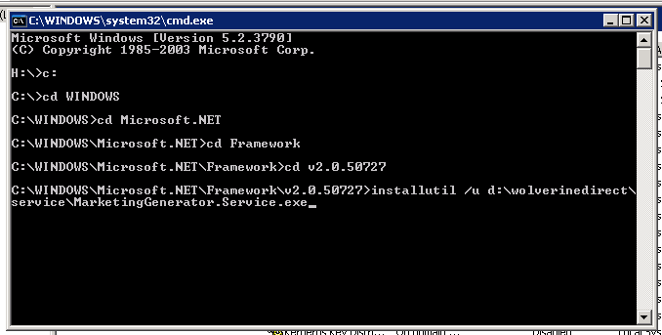

Install the new version:

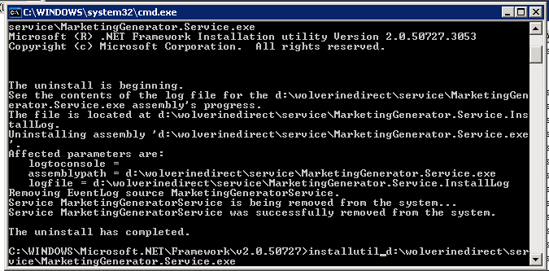

**This will need to be done if any changes are made to the config file located in the service folder. Changes do not get applied by simply restarting the service.**

## Starting the service

To start the service, go to Administrative Tools > Services. Find the Marketing Generator Service~~, right click and select Properties. In the parameters field, you must specify the folders to monitor in the using the following:~~

**~~‘-path=D:\WolverineDirect\US -pathca=D:\WolverineDirect\Canada -checkbrands=true’~~**~~.~~

~~‘-path’ set to the US folder, ‘-pathca' set to the Canada folder~~ ~~and checkbrands set to true to make sure all brands are present in the ITE file~~. Hit Start ~~once the parameters are entered~~.

**UPDATE 5/23/12:** Since the folder structure is static and doesn’t ever change, I’ve opted to remove all command line parameters and hard code the folder locations in D:\WolverineDirect. As for the checkbrands flag, that has been moved to the config. The service is set to start automatically.

**~~EDIT 4/10/2012:~~** ~~Due to the service not starting automatically and days being missed uploading data to Hybris when the server is rebooted, I have since found a solution for adding parameters to a service that is started automatically. Simply add the parameters to the service in regedit. This is in HKEY_LOCAL_MACHINE\SYSTEM\CurrentControlSet\Services\MarketingGeneratorService. Edit the ImagePath value.~~ **Obsolete**

## Using the service

Once the service has been started, simply open the folder that was specified in the parameters and place all the Excel files you wish to be read. A nightly process has been created in RoboMon to place the SAP generated files into the US & Canada folders on ROCAPP01. Once all of the files have been transferred into the folder, a flag file, “IC*.DON”, is renamed to “IC*.SND”. In the US folder, it is IC1; in the Canada folder, it is IC2. This triggers the service to read the excel spreadsheets, compare the data against the newly added ITE, generate the marketing files and images, and send all the SAP, marketing, and image files to the iCongo FTP server. Once everything has been sent to iCongo, the IC*.SND file is renamed back to IC*.DON to let RoboMon know that the process has completed.

One thing to note: ~~The Marketing Info Generator service uses the same database for US and Canada, so only one should run at a time. The RoboMon process has been set up accordingly to allow for this. The US will run first, set the IC flag to let RoboMon know it’s done, then run the Canada process.~~

**UPDATE 5/23/12:** The folders for WarehouseExport and FactoryDirect were added for international. These will have the file IC3.DON and IC4.DON, respectively. Also, due to the added processes, it was necessary for these jobs to run simultaneously so I have altered the service to allow for this.

Here is what the folder should look like to be prepared for the RoboMon process:

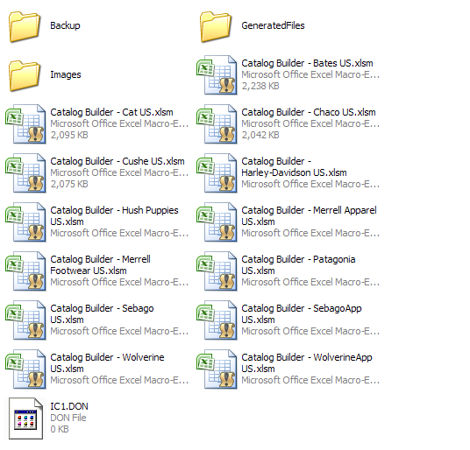

A service set up for staging has been created on ROCWEB01 with the same paths and settings as production. The only difference is that it points to the database on ROCSQT01.

# Log File

Log files to monitor the process are stored on the respective servers (ROCWEB01 for staging and ROCAPP01 for production) under **C:\Logs**. This is useful to watch when running to make sure everything runs smoothly. If you wish to receive error emails, you can modify the config file and add your email address to the log4net section. If you modify the config file, you must uninstall and reinstall the service for the changes to take effect. ~~Don’t forget to start it up again with the parameters as well~~. It’s automatic now with no parameters.